Cortana Chip Style Arduino Casing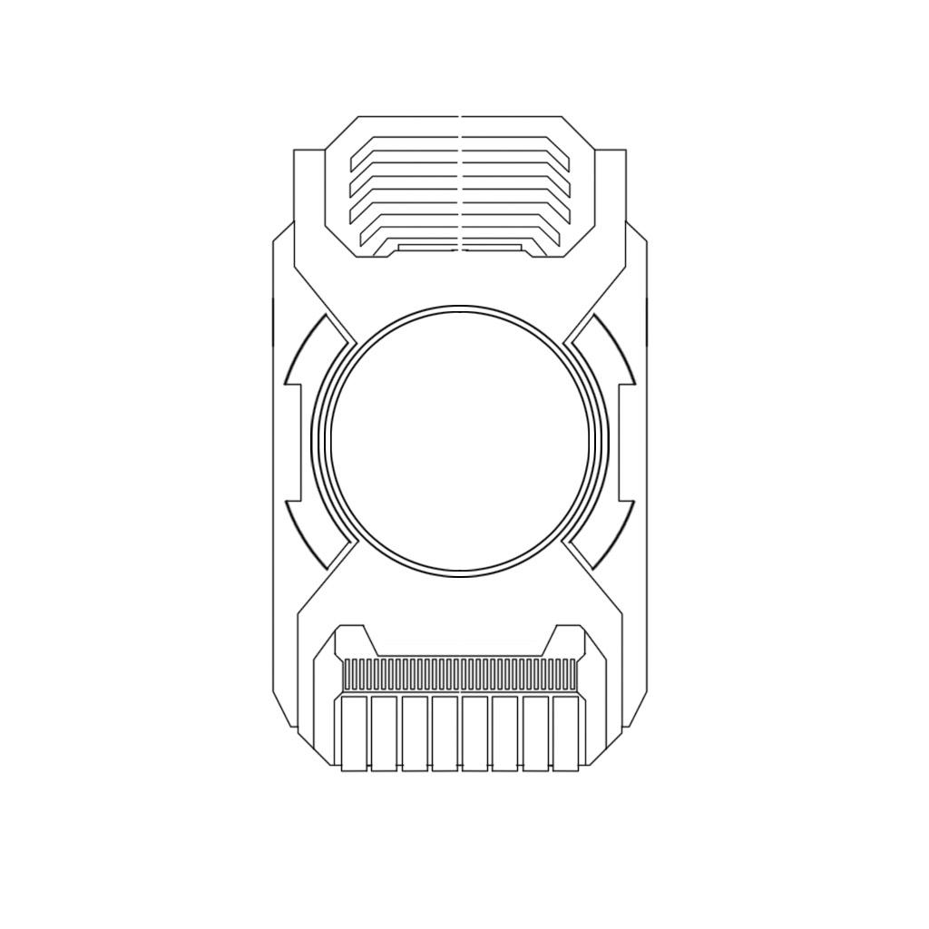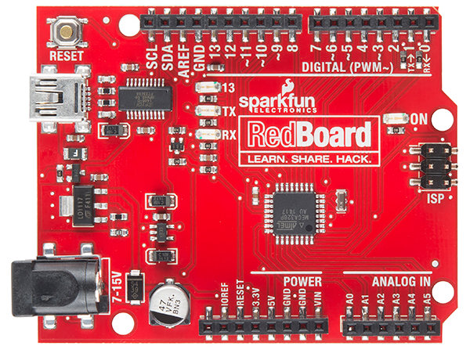

The case I made is based on a graphic design of a AI computer chip in a video game called Halo. The chip comes in many designs but all revolve around a few simple concepts: A circular portion in the middle, a serrated set of horizontal ridges, and a row of metal contacts. The shape is that of a very long octagon. This is one example of the design.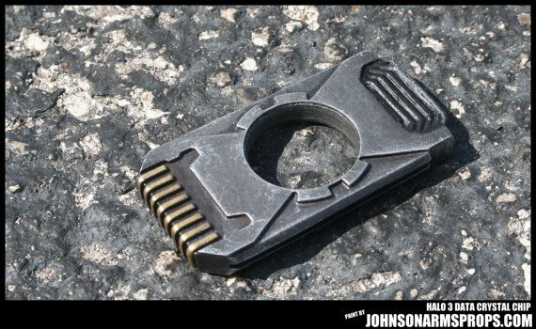

One function particular to this case that I wanted to add was the ability to fit both the arduino and the breadboard, including wiring between the two. A few challenges arose from this. First, the footprint of the case had to be very large to fit the two boards cleanly. Second, the design needed to be very tall to accommodate the wiring. This resulted in a very costly design. Finally, the top of the design must be removable to give access to the boards. To overcome the size limitations and the cost of this, I fit three layers each onto six sixteen inch by twelve inch sheets of acrylic. By buying a forty eight by twenty four inch of acrylic and cutting it into these sheets, I was able to save money on the acrylic. It will have to be very sizable in order to fit the boards and still match the design. To overcome the challenge of accessing the boards, I made a row of five holes on either side of the layers. The top layer with have long poles that can insert into these holes so that the top layer will hold in.

